**COFFEE DAY ORDERING SYSTEM  
QUESTION:**

Draw a coffee day ordering system. A coffee day shop vending machine dispenses coffee to customers. Customers order coffee by selecting a recipe from a set of recipes. Customers pay for the coffee using coins. Change is given back, if any, to the customers. The ‘service assistant’ loads ingredients (coffee powder, milk, sugar, water, chocolate) into the coffee machine. The ‘service assistant’ adds recipe by indicating the name of the coffee, the units of coffee powder, milk, sugar, water, chocolate to be added as well as the cost of the coffee. The service assistant can also edit and delete a recipe. Develop the use case diagram for the specification above.

**AIM:**

To develop a **Use Case Diagram** for a **Coffee Day Shop Vending Machine** that allows customers to order coffee, make payments, receive change, and enables the service assistant to manage ingredients and recipes.

**PROCEDURE:**

1. Identify actors: Customer and Service Assistant.

2. Define use cases: Order Coffee, Make Payment, View recipe & Get menu, Load Ingredients, Add/Edit/Delete Recipe.

3. Draw the Use Case Diagram connecting actors to relevant use cases.

**DIAGRAM:**

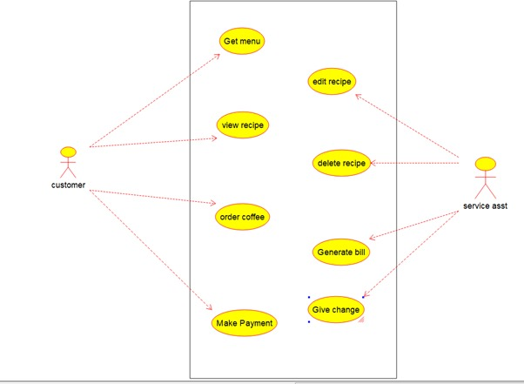

**RESULT:**

The **Use Case Diagram** for the **Coffee Day Shop Vending Machine** was successfully created.